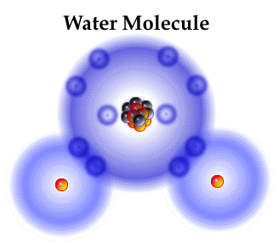
Water

Objectives:
- Model the states of water and the principle of hydrogen bonding
- Conduct an experiment to demonstrate surface tension
- Conduct experiments to demonstrate adhesive and cohesive forces
- Understand how water moves through a stem and why transport is important to sustain plant life

Background:
Stems produce and support the shoot system of plants. The shoot system is the above ground portion of a plant and is composed of systems, leaves and reproductive organs. Stems function in the transport of water, minerals and food; the display of leaves, structural support, storage, sometimes photosynthesis and reproduction. Did you know that celery is the stem of the plant? Has anyone ever seen a bouquet of flowers in a vase of water? Why do we put the flowers in water? Have you ever tried to die a piece of celery with food color?? Can you see the water going into the flowers or the celery? Not really, but the celery and flower experiment with food coloring helps us visualize this process. After several hours in the dyed water the celery stalk shows signs of dye moving up the stalk, but only in the fibers, not throughout. Evidence of movement of the dyed water in the celery is seen in the tinged leaves. The tissue stained by the food coloring is the xylem tissue. The celery stalk is transporting the water only in those cells that are stained.
Water is made up of molecules. A molecule is a group of atoms that are held together by chemical forces (bonds). Each water molecule is made up of two hydrogen atoms and one oxygen atom, creating H₂O. We experience water in three states of matter: vapor, liquid and solid. When water is in the gaseous state (vapor), the molecules are separate and independent. In the liquid state, the hydrogen atoms form a weak attraction between the water molecules (this is a hydrogen bond), holding them together and creating the properties of liquid water. In the solid state, ice, hydrogen bonding firmly holds the molecules together in a six-sided lattice pattern.
Water molecules have poles, like magnets; one end has a negative charge and the other has a positive charge. They are referred to as polar molecules. The positive end of one molecule is attracted to the negative end of another molecule. When the molecules stay in contact with each other, a bond called a hydrogen bond, forms between the two molecules. The structure and nature of water molecules give it various properties that are critical to life.
Because of the polar nature, a water molecule is attracted to other water molecules and also to molecules of other substances. The attraction between water molecules is called cohesion and the attraction of water molecules to other substances, like soil or glass, is called adhesion. Without these properties, plants could not upwater water through their roots into their stems and leaves through capillary action.
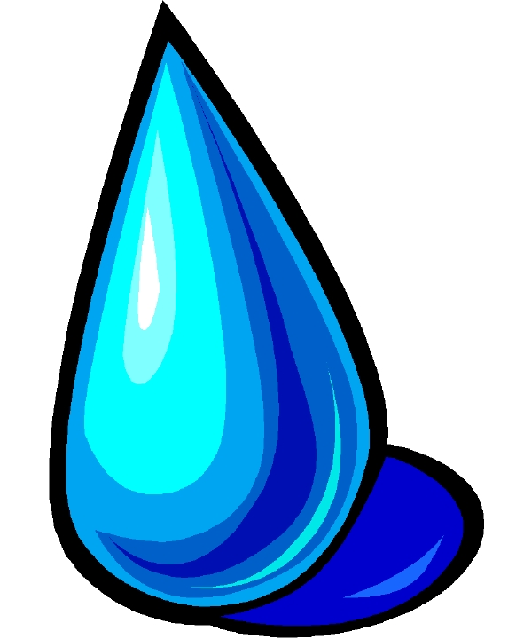
You see how water molecules are attracted to each other by looking at a glass filled to the brim with water. When you add more water very slowly, the level of the water rises in a small dome above the rim of the glass. The liquid water molecules are strongly attracted to each other, but not to the gas molecules above the water surface. The cohesive force between water molecules cause the water surface to behave as though it is a thinly stretched membrane that is always trying to contract. This phenomenon is called surface tension. In many ways, surface tension is like the water’s skin.
The same forces that cause water molecules to be attracted to each other cause them to adhere to other substances. If this didn’t happen, water would slide off of everything like it does when it comes into contact with oil. Water appears to defy gravity as it moves up a paper towel or through spaces between soil particles. This is called capillary action. It results from water molecules being attracted to molecules of the paper towel or the soil, and to each other. The molecules can only travel this way to a point where the force of gravity overcomes the forces of attraction.
Water does 5 very important things for all living creatures using the above-mentioned ideas. These are its biological roles:
- Water acts as a solvent
  - This means that water is capable of dissolving many different substances
- Water acts as an insulator
  - Water has a maximum density when it is just above its freezing point. Ice Layers therefore float and insulate the water below the surface of ponds and lakes
- Water acts as a moderator of temperature changes
  - Water absorbs a lot of heat when changing states. Loss of heat through evaporation cools us when we sweat.
- Water acts as a transport medium
  - Because of its hydrogen-bonding and solvent properties water is an important transport medium for living things. It helps to move minerals and nutrients through stems, and helps with blood in the human body.
- Water acts as a reagent
  - Water is particularly important in some chemical reactions.

Pre lab questions (WRITE THE QUESTION AND ANSWER ON A SEPARATE SHEET OF PAPER)

- Why is transport important in the stem of a plant?
- What tissue in the stem allows water to flow through it?
- What is a bond?
- Describe a hydrogen bond
- Why is water considered a polar molecule?
- Describe 5 biological roles of water
- What is the difference between cohesion and adhesion?
- What is surface tension?
- What is capillary action?
- How is transport in the stem of a plant different/similar then in our cells?

Rowing: Water bonds

We are going to move outside today and simulate water moving through the various stages. The team that wins is the team that stays in the game the longest!
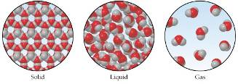

Questions:

- Describe what the group looked like when they were at a vapor/gas stage

- What started to occur to the group when condensation started taking place and we started turning into a liquid?

- What does this simulate?

- What started to occur to the hydrogen bonds as the group started to freeze? Draw a picture

- Explain how the various stages interact with plants
Diving Competition: Surface Tension
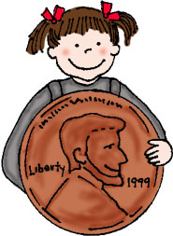
Surface tension refers to water's ability to "stick to itself". Surface tension can be measured and observed by dropping water (drop by drop) onto a quarter. The number of water drops that can fit on a quarter will surprise you.
1. Predict how many drops you will be able to place on the quarter, and place these numbers in the data chart
2. Test your prediction by comparing the number of drops of tap water that can fit on a quarter to the number of drops of soapy water that can fit on a quarter. Because water drops may vary depending on how well you drop the water, it is best to run many trials and take an average. Record your data in the table below
 | Prediction | Trial 1 | Trial 2 | Trial 3 | Average
Tap Water
Soapy Water

- Explain what surface tension is.
- At what point were adhesive forces occurring? How do you know?
- At what point were cohesive forces occurring? How do you know?

Sculling: Surface Tension – HAVENT DONE

Surface tension is the property that makes the surface of water appear to have a sort of elastic "skin," and is caused by the way water molecules are more attracted to each other than to the air. When your boat sits in the water the surface tension is the same on all sides. When you put the drop of soap near the back, however, the soap molecules break the water's surface tension. The force of the surface tension pulling on the front of the boat is now greater than the force pulling behind, so the boat moves forward.

Procedure:
- Cut out a boat shape from a piece of cardboard (see pattern below)
- In the rear of the boat, cut out a small notch.
- Place a drop of liquid detergent in the notch of the boat
- Place the boat in a tray of water.
- Describe what happens: __________________________________

- Design a “better” shape for the boat so that it will move faster - you may change the shape or amount of soap you use. Try to keep the boat about the same length.
- Try putting it in the water and compare results with your first boat.
- Chose the best design and place the boat at one end of the tray (starting line).
- Start the timer until the boat crosses the finish line (opposite side of the tray.)
  - Fastest boat wins!
- Repeat the “race” until all members of your team has raced their boat.

Boat Number | Time 1 | Time 2 | Time 3 | Average

1. (everyone the same)

2. (better shape)

Sailing: Adhesive Forces

Adhesion is the molecular attraction exerted between unlike substances in contact.

Procedure:
- Fill the cup to the brim with water until it forms a bubble on top.
- Place a paper clip flat on the edge of the fork tines.
- Gently place it on the surface of the water.
- You may need to try this several times. If one falls through, try with another paper clip.
- Repeat until you can place no more on top.
- Record your results and find the mean of your groups.

Trial Number | Prediction | Number of paper clips
1
2
3
Average

Was your prediction anywhere close to the actual number? Why or why not?

Explain how adhesive forces helped the paper clips stay afloat

- Did your technique affect how many paper clips fit on the surface? Why or why not?

- How do adhesive forces work in plants?

500 M Relay: Cohesive Forces

Cohesion is the molecular attraction exerted between molecules that are the same,
such as water molecules.

Procedure:
- Cut a piece of yarn 1 foot long
- Place into a beaker that has been filled with water
- Have one person hold the yarn up, and have the other end dangling in an extra beaker
- Have a different person slowly pour water on the yarns top
- Collect water in the beaker for 1 minute
- Measure how much water you have collected
- Do this over again with different lengths of yarn

Yarn length | Water collected in ml
1 ft
5 ft
10 ft
50ft

- What distance was the easiest to have water fill the beaker? Why?

- What distance was the hardest? Why?

- Explain how cohesive forces helped collect more water

- Explain how cohesive forces work in a plant stem

Synchronized Swimming: Cohesive Forces

Procedure:

- Fill a small cup with water to the top without spilling over.
- Slowly add pennies to the cup of water one at a time.
- Do this until the water falls over the side of the cup
- What does the side of the cup look like as you add more pennies? Draw the side view below:

Trial Number | Prediction | Number of pennies
1
2
3
Average

Was your prediction anywhere close to the actual number? Why or why not?

Explain how cohesive forces helped the water not spill over the top of the cup

- Did your technique affect how many pennies you could put into the cup? Why or why not?

